**1.EQUI JOIN:**

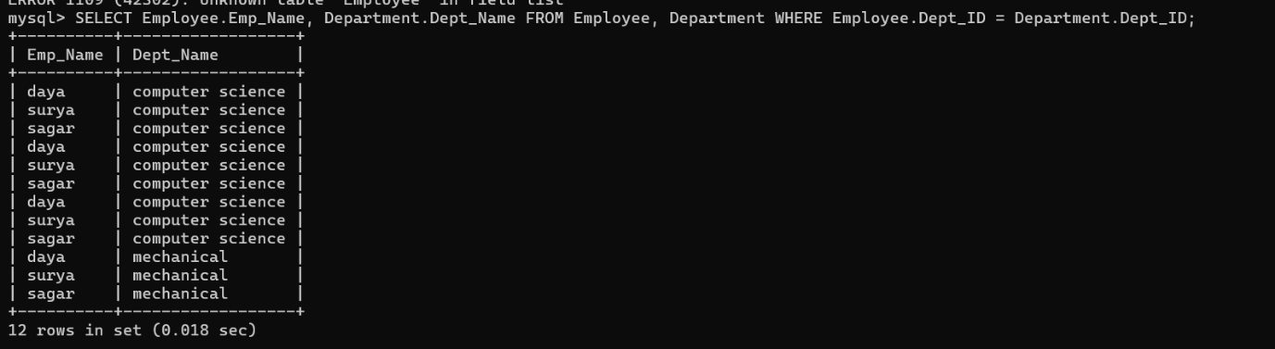

**2.INNER JOIN:**

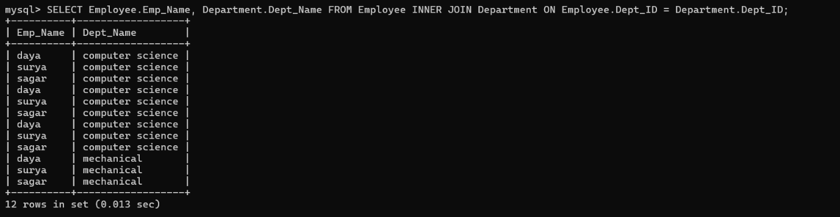

**3. OUTER JOIN (LEFT AND RIGHT):**

